|  |
| --- |
| (A) REQUEST DETAILS |

|  |  |  |  |
| --- | --- | --- | --- |
| Change Request No: | CR_AC_2012_0014_SG | Request Date: | 11 Sep 2012 |
| Request By: | Chong Hwang | Client Name: | Apple Care |
| Priority  (E/H/M/L): | H | Application: | Hub Application |
| Expected Date of Completion: 8 Oct 2012 | |  | |
| Request Title: | AC - Indonesia Buy-Sell | | |

Nature of Request (please tick):

|  |  |  |  |  |  |  |  |
| --- | --- | --- | --- | --- | --- | --- | --- |
| Errors |  | New |  | Modifications |  | Others (please specify) |  |

**Revision History**

|  |  |  |
| --- | --- | --- |
| **Version No.** | **Modified By, Date** | **Description** |
| 1.0 | Chua Chong Hwang/2012-09-11 | 1. Initial Draft |
| 1.2 | Chua Chong Hwang/2012-09-25 | 1. Rename DeliveryGroup to DeliverySortCode 2. Delivery Sort Code value changed to 4 numeric digit |

|  |
| --- |
| **Country affected:**  - SG  **REQUEST DESCRIPTION** |

For Indonesia shipments, required to group by the additional fields

Transportation Zone

Delivery Sort Group

**Changes:**

1. Table – Main and Archive Databases – SQL scripts to be provided by SSC
   * 1. Orders – New field

|  |  |  |
| --- | --- | --- |
| **Field** | **Type** | **Length** |
| DeliverySortCode | Varchar | 30 |

* + 1. BAX_HAWB – New field

|  |  |  |
| --- | --- | --- |
| **Field** | **Type** | **Length** |
| MAWB | Varchar | 30 |

* + 1. BAX_HAWB – New index

|  |
| --- |
| **Field** |
| MAWB |

1. Table – SQL scripts to be provided by SG IT
   * 1. Codelist – New record

|  |  |
| --- | --- |
| **Listname** | **Description** |
| DELR_SORT | Apple Care Delivery Sort Code |
| PSI_EMAIL | Email Address for Indonesia PSI Aging Report |

* + 1. Codelkup – New record

|  |  |  |
| --- | --- | --- |
| **Listname** | **Code** | **Description** |
| DELR_SORT | 1111 | PSI Dutiable WIFI |
| DELR_SORT | 2110 | PSI Dutiable |
| DELR_SORT | 3101 | PSI WiFi |
| DELR_SORT | 4100 | PSI only |
| DELR_SORT | 5011 | Dutiable WiFi |
| DELR_SORT | 6010 | Dutiable only |
| DELR_SORT | 7001 | WiFi only |
| DELR_SORT | 8000 | None |
| PSI_EMAIL | 1 | Email address to be provided |
| PSI_EMAIL | 2 | Email address to be provided |

1. Hub
   1. Hub Menu
      1. New menu category for Indonesia shipment
   2. Order Sortation – existing
      1. Retrieve only DNs with Ship To Country <> ‘ID’
   3. New screen: Order Sortation - Indonesia
      1. Retrieval
         1. Only retrieve DNs with Ship To Country = ‘ID’
      2. Order Grouping
         1. Based on current Order Sortation (Local) and add another 2 fields to the grouping:
            1. Transportation Zone
            2. Delivery Sort Code
      3. Screen Changes
         1. Add the 2 fields (TZ and Delivery Sort Code) on screen after ‘Add3’

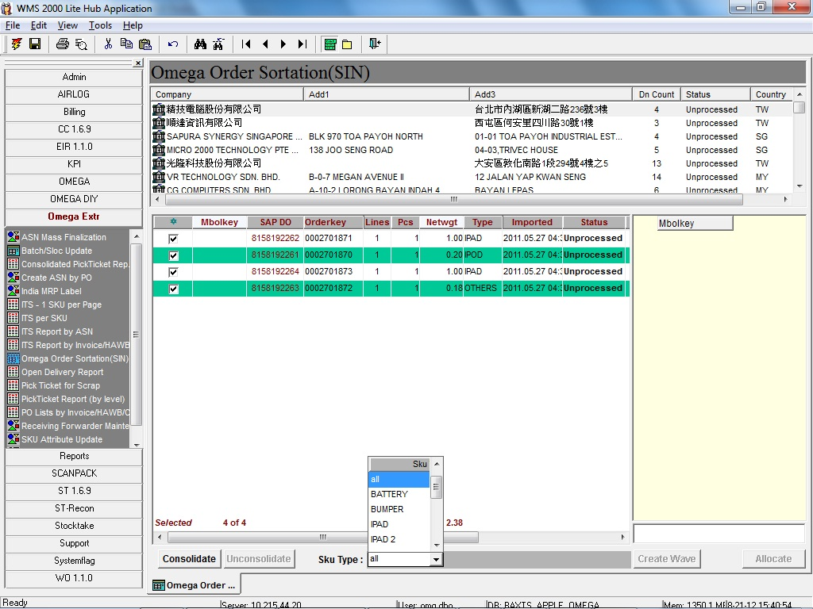

Add new column TZ and Delivery Sort Code

* 1. Pick Tickets
     1. Composite Report
        1. Retrieval Parameter
           1. Wavekey
        2. Pick Ticket Summary Page
           1. Format as follow

A4 Size

Wave Pick Ticket Summary

Wave# Mbolkey TZ Delivery Sort Code

0000000001 SG00000001 ID000001 7001 Wifi Only

0000000002 SG00000002 ID000002 3101 PSI, Wifi

* + - 1. Consolidated Pick Ticket
         1. This is the same as the existing Consolidated Pick Ticket
  1. Pick Ticket - Indonesia (group by Mbolkey)
     1. Retrieval Parameter
        1. Wavekey
     2. Format
        1. Following existing Pick Ticket format with the following changes
           1. Add Delivery Sort Code description (use bold font) above the Ship To Address
  2. Invoice/Packing List/DN - Indonesia
     1. Screen layout
        1. Copy from the existing screen but add retrieve by MAWB
     2. Retrieval Parameter
        1. Remove the logic that if select PL only, to retrieve only by HAWB#, if select DN only, to retrieve only by Mbolkey, etc
     3. Invoice
        1. Group By
           1. MAWB
        2. Header Change
           1. Rename ‘HAWB #/BL #’ to ‘MAWB #’ and print the MAWB#
           2. Print ‘SG’ + MAWB as the Invoice Ref
        3. Address Logic
           1. Sold From Address (Sales Org address)

Retrieve from Storer table using Orders.SR

* + - * 1. Sold To Address

Retrieve from Storer table using Orders.Organisation

* + - * 1. Ship To Address

Retrieve from Storer table using Orders.Organisation

* + 1. Packing List
       1. Group By
          1. MAWB
       2. Header Change
          1. Rename ‘HAWB:’ to ‘MAWB:’ and print the MAWB#
          2. Print Sold To and Ship To addresses on the Packing List in the same position as for Invoice
       3. Address Logic
          1. Sold From Address (Sales Org address)

Retrieve from Storer table using Orders.SR

* + - * 1. Sold To Address

Retrieve from Storer table using Orders.Organisation

* + - * 1. Ship To Address

Retrieve from Storer table using Orders.Organisation

* + 1. Delivery Note
       1. Group By
          1. Mbolkey
       2. Address Logic
          1. Sold From Address (Sales Org address)

Retrieve from Storer table using Orders.Organisation

* + - * 1. Sold To Address

Print Sold To address from Orders

* + - * 1. Ship To Address

Print Ship To address from Orders

* 1. PSI Aging Report
     1. Automatic generated report to be sent every morning
     2. Auto email to email addresses from Codelkup table with Listname = ‘PSI_EMAIL’
     3. Format = Excel
     4. Retrieval Logic
        1. Retrieve un-shipped DN that requires PSI (Codelkup.Description like ‘%PSI%’)
        2. Sort by Aging days desc, DN#
     5. Report Fomat:

|  |  |  |  |  |  |
| --- | --- | --- | --- | --- | --- |
| **PSI Aging Report** | | | | | |
| **5/9/2012**  Report run date | | | | | |
| **S/N** | **DN #** | **HAWB** | **Delivery Sort Code** | **DN Dropped Date** | **Number of days** |
| 1 | 812345678 | 12345678 | 1111 | 3/9/2012 | 2 |
| 2 | 812345679 | 12345679 | 2110 | 3/9/2012 | 2 |
| 3 | 812345680 | 12345680 | 2110 | 3/9/2012 | 2 |
| 4 | 812345681 | 12345681 | 2110 | 3/9/2012 | 2 |
| 5 | 812345682 | 12345682 | 3101 | 3/9/2012 | 2 |

Number of days = Today’s date minus DN dropped date